Unit 5, Session 4
The People Built the Tabernacle (Exodus 35–40)
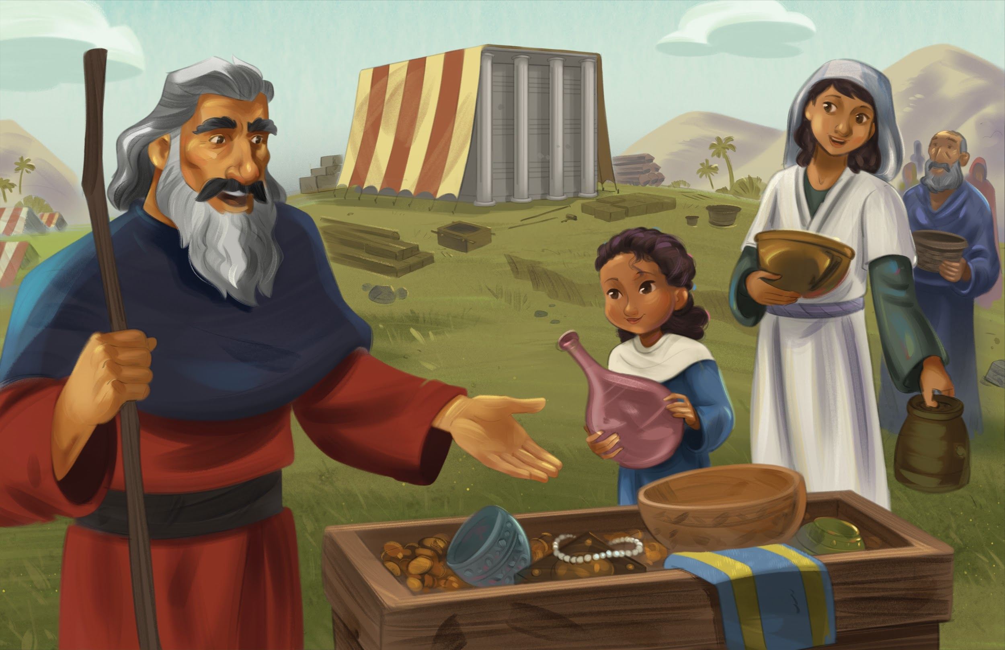
Dear families,

One of the key themes of the Bible is God’s desire to live with the people He created. We see this first in God's creating the garden of Eden, placing Adam and Eve into this paradise, and then presumably coming down regularly to be with them.

But when Adam and Eve rebelled against Creator God, one consequence of their sin was expulsion from the garden. No longer would God live with them as He had before.

Generations later, God instructed His people to do something curious: build a tent. Why? This tent, the tabernacle, would not be a place for treasures or food; no animals or people would live in it. This would be God’s tent, where He would dwell among His people, pointing back to Eden.

Whenever the Israelites traveled, they broke down this tent and carried it with them. Then, when they arrived at their destination, they set up the tent once more—strategically and meaningfully placed in the center of the camp. God was not just with His people, He was at the center of His people. That was the place He deserved.

Note one feature of the tabernacle that would later give way to the permanent temple built in Jerusalem: the veil, or curtain. The innermost chamber of the tabernacle was called the holy of holies, or most holy place. This is where God’s presence would be manifested above the ark of the covenant and mercy seat. This sacred area was separated from the next outer chamber—the holy place—by a heavy curtain.

We later learn in Leviticus that only the high priest could enter into the holy of holies once a year—on the Day of Atonement. This curtain, then, was a picture of the ongoing separation between humanity and God because of sin. God wanted to dwell with people, but sin was preventing that from happening in full.

When Jesus came and paid the sin penalty for people, that curtain tore from top to bottom, symbolizing that entry into the holy of holies had been made through Jesus. But sin continues to corrupt the world, which is why one day Jesus will return, put an end to sin and death, and renew creation.

This is how the story of Scripture ends in Revelation—with Christ establishing His kingdom in a new heavens and earth and dwelling with His people forever. What God intended from the beginning will mark the beginning of eternity.

Check out The Gospel Project At Home for resources designed to help you lead a family worship experience as well as suggestions for morning and evening prayer times and family activities.

FAMILY TALKING POINTS

CHRIST CONNECTION
This is the big idea of how this week’s Bible story points to Jesus.

- Babies & Toddlers: God sent Jesus to be with people.
- Younger Preschool: God’s people built a tabernacle where they could worship God together. God wants to be with us. God sent Jesus to earth to be with people.
- Older Preschool: God told His people to build a tabernacle where He would meet with them. God wants to be with us. As part of His plan to save people from sin, God sent Jesus to earth to be with people.
- Kids: God told the Israelites to build a tabernacle where He would dwell with them. God wants to be with His people. As part of His plan to save sinners, God sent Jesus to dwell on earth with people.

BIG PICTURE QUESTION & ANSWER
This is an important biblical truth that your child will encounter each week of this unit.

- Younger Preschool: What is worship? Worship is singing, praying, and listening to God.
- Older Preschool: What is worship? Worship is celebrating the greatness of God.
- Kids: What is worship? Worship is celebrating the greatness of God.

KEY PASSAGE
This is a Bible verse that relates to what your child will encounter each week of this unit.

- Babies & Toddlers: Let’s worship God. — Psalm 95:6
- Younger Preschool: Let’s worship God. — Psalm 95:6
- Older Preschool: Come, let’s worship and bow down; let’s kneel before the LORD our Maker. — Psalm 95:6
- Kids: Come, let’s worship and bow down; let’s kneel before the LORD our Maker. For he is our God, and we are the people of his pasture, the sheep under his care. — Psalm 95:6-7

** Next week: God Deserves Our Worship (Leviticus 1–4)

